**WEBINAR REPORTS**

**Extension Lecture organized on Research funding**

Research and Development Cell of DAV College, Abohar organized an extension lecture on the topic Ethics in Research, Research Funding Agencies, Preparation of Research Proposals & Research Collaboration on 5th March, 2024 in the college seminar Hall. Dr. R. K. Uppal, Principal, Baba Farid College of Management & Technology, Bathinda was the invited academician.

Dr. Uppal in his talk began with the ethics why these are required in academic research and what the consequences are of violating these by the scholars. The main thrust of his talk was preparing research proposals. He guided the participants regarding the formats of major and minor proposals. He also stressed on the need of relevance of a specific study and how the significance of a work need to be carefully drafted keeping in mind the ongoing issues faced by any country or a society. He had a detailed list of the disciplines where research can be carried out along with the detailed numeration of significant Research funding agencies in every discipline.

He also stressed on the need of interdisciplinary research by collaborating with colleagues from the same institution or from different states and countries. He had practical tips regarding a better h-index for the researchers. He also spoke at length regarding the need of getting more patents registered by scholars in India.

On the whole, the lecture was quite informative and purposeful. All the participants had their queries satisfied by the learned scholar. Dr. Kiran Grover presented a vote of thanks to the esteemed speaker.

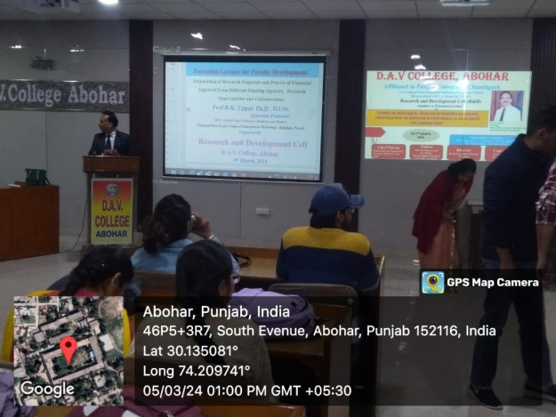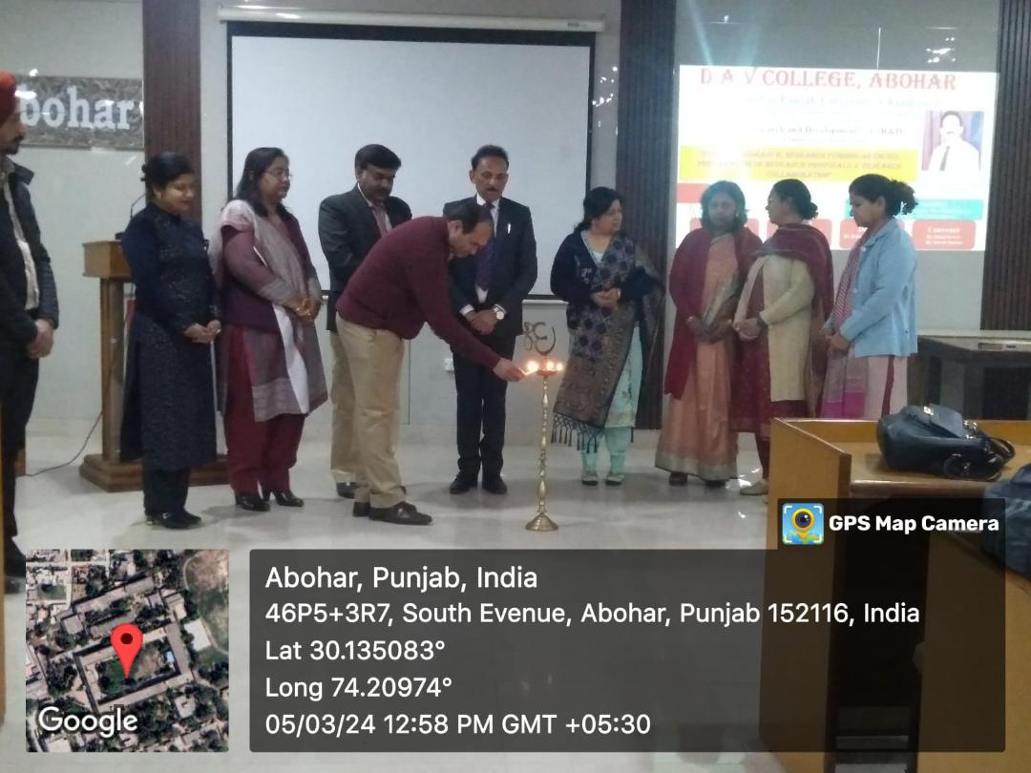

**Lecture on Opportunities and Challenges for Women Entrepreneurs**

P.G. Department of Commerce and Business Management organized an interactive session on “Opportunities and Challenges for Women Entrepreneurs” on 5th March 2024 at 11.30 A.M. in seminar Hall. The purpose of the session was to encourage the students about entrepreneurship and make them aware about the challenges and solutions of she-preneurs by presenting live examples of the female entrepreneurs of the town. Mrs. Ritu Beri (Founder & Principal of Fun school, Abohar) and Ms. Gehna (Founder and owner of Sugar Layers, Abohar) were invited as resource persons. Both of them shared their journey towards becoming successful women entrepreneurs.

Mrs. Ritu Beri shared how she started her career in this field 17 years ago in a small room. Now, she is running number one school in the town with approximately 200 students in pre-primary section. She motivated the students by sharing her experience regarding the opportunities and hurdles in her way of becoming a successful entrepreneur.

Ms. Gehna also shared her career journey. She told the students how she started her journey from scratch in corona times to one of the leading bakers in the town. She had given her day and night to convert her passion into the profession. She is the perfect example of becoming a successful women entrepreneur and a self made successful entrepreneur as well.

The session was attended by around 70 students of commerce. The resource persons effectively answered the various queries of the students present there. At the end of the session the feeling of motivation and enthusiasm of the students was quite high.

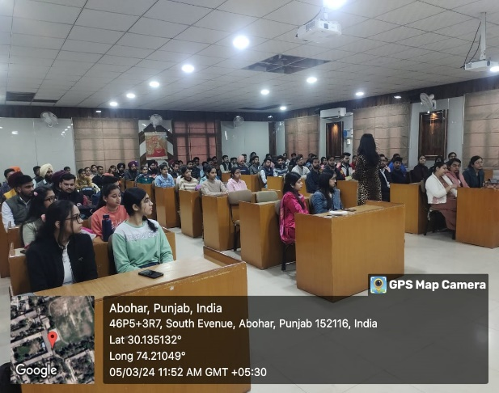

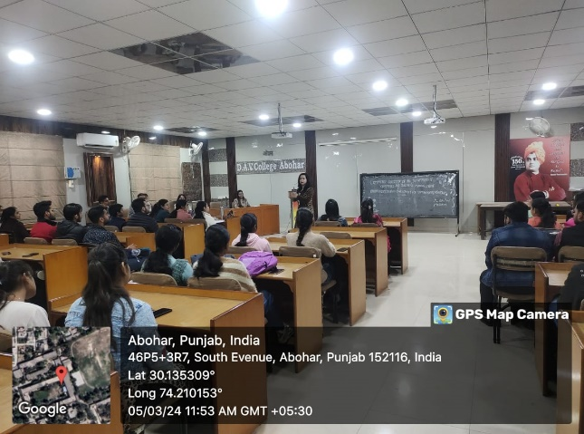

**Seminar on Intellectual Property Rights**

PG Department of Chemistry and IQAC under the dynamic leadership of Principal Dr. Rajesh K. Mahajan organized a Seminar on Intellectual Property Rights by Dr. Jitender Sharma, Assistant Controller of Patents and Designs, Indian Patent Office, Ministry of Commerce and Industry, Government of India. Dr. Sharma gave a detailed account of Copyright, Patents, Design, Geographical indications and framework.

About 100 students attended the seminar and gained new insights. At the end Dr. R. K. Mahajan gave a vote of thanks to the speaker and organizing committee for successful execution of seminar.

